Blackwood Health Center

Name Date / /
Home Address
City State Zip Email
Birth Date / / Sex M F Height Weight
Home Phone Work Phone Cell Spouse’s Name
What is your major health concern?
When did this problem first begin?
Are you currently in pain or having symptoms? Yes No None 1 2 3 4 5 6 7 8 9 10 severe
How long have you been in pain? Days Weeks Months Years
What makes it better? What makes it worse?
Have you ever had this problem in the past? Yes No How many times?
Does the problem affect your daily activities at work? Yes No Home? Yes No
Other health concerns

Current medications, dosage and type

How many times have you been treated with Antibiotics?

When was the last time? For what condition?
Current nutritional supplements and herbal products brand and amounts taken

Do you have any allergies, Seasonal? Food? Etc.

Have you had any X-rays in the past 2 years? Yes No If yes, what for?

Have you ever suffered from or been diagnosed with any of the following? (Circle Y or N)
Broken Bones | Y N | Osteoarthritis | Y N | Gall Stones | Y N
Circulatory Problems | Y N | Pacemaker | Y N | Head Injury | Y N
Rheumatoid Arthritis | Y N | Strokes | Y N | Anxiety | Y N
Seizures/Convulsions | Y N | Epilepsy | Y N | Eating Disorder | Y N
Congenital Disease | Y N | Cancer | Y N | Coughing Blood | Y N
Excessive Bleeding | Y N | Ulcers | Y N | Diabetes-Type 1 | Y N
High Blood Pressure | Y N | Low Blood Pressure | Y N | Diabetes-Type 2 | Y N
Depression | Y N | Low Thyroid | Y N | High Thyroid | Y N

On the diagram below, please indicate where the pain is and use the letters to indicate the type of pain.
Back
Front

A | Aching
B | Burning
C | Cramping
D | Dull Throbbing
E | Electrical Shock
J | Joint
M | Muscle
N | Numbness
S | Sharp
T | Tingling
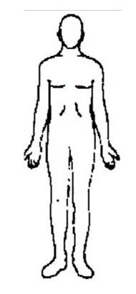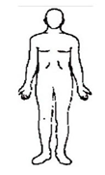
Lifestyle Profile

Do you smoke? Yes No If yes, how much and for how long?
Do you drink alcohol? Yes No If yes, how much and how often?
How many times per week do you exercise? What type? How many hours do you sleep per night? Do you wake during the night? Yes No
Do you have difficulty getting to sleep? Yes No Do you feel rested in the morning? Yes No
On a scale of 1(low) – 10 (high) what is your energy level like in the
Morning Afternoon Evening
Do you suffer from mood swings? Yes No Do you suffer from depression? Yes No
Do you have children?

I clearly understand and agree that all services rendered to me or my dependent is charged directly to me and that I am personally responsible for payment.

Signature Date

Consent to treat a minor
I herby Authorize: Dr. Lee Blackwood DC and whomever he may designate as assistants to administer chiropractic care for my Son / Daughter.
Name of child Date Signed
(Parent or Guardian)

